Gilgit:

Trango Towers

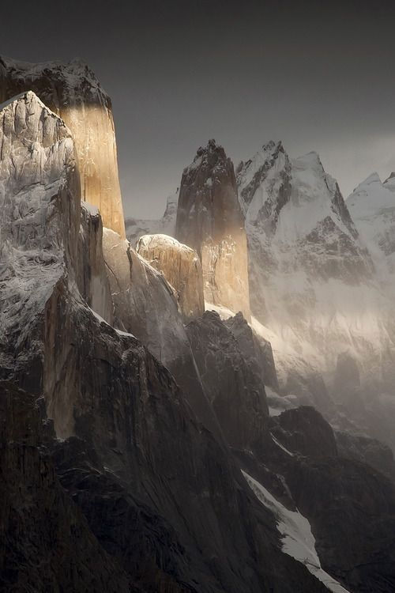

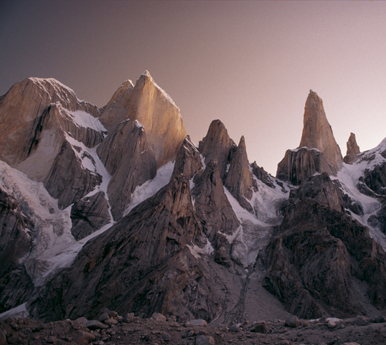

The **Trango Towers** are a family of rock towers situated in Gilgit-Baltistan, in the north of Pakistan. The Towers offer some of the largest cliffs and most challenging rock climbing in the world, and every year a number of expeditions from all corners of the globe visit Karakoram to climb the difficult granite. They are located north of Baltoro Glacier, and are part of the Baltoro Muztagh, a sub-range of the Karakoram range. The highest point in the group is the summit of **Great Trango Tower** at 6,286m (20,623ft), the east face of which features the world's greatest nearly vertical drop.